Prof. Anna Maria Salvi

Contacts
Sciences Department (DiS)
Viale dell'Ateneo lucano, 10 - 85100 Potenza
Email: anna.salvi@unibas.it
Tel. +39 (0971) 20 6256 20 6255 (XPS lab.)
Fax +39 (0971) 20 5678
Cell. +39 320 423 8516

Education
Degree in Chemistry (110/110 a.a.1982/’83) and Professional Habilitation (1984) awarded at the University of Rome 'La Sapienza' Italy
‘Visiting Scientist’ at the University of Surrey, FEPS Department, Guildford (UK) for several periods from 1988 onwards. Enrolled in a part time PhD program for the academic quinquennium 1990-1996 under the supervision of Prof. J.E. Castle. PhD awarded in 1996 for the thesis entitled, "The relationship between atomic number and the intensity of the energy loss structure of the photoelectron spectrum" at the University of Surrey, England.

Employment
1984 –1986 University of Rome: Collaborative research with Prof. Luigi Campanella’ research group (analytical chemistry)
1986 University of Basilicata: Researcher (Permanent Position) in Analytical Chemistry
1998– Present time University of Basilicata: Associate Professor of Analytical Chemistry.

Teaching activity
- Analytical Chemistry (LT Basic Courses)
- Analytical Chemistry of Surfaces and Interfaces (LM Basic Courses)

See detailed information from ESSE3 on http://docenti.unibas.it/site/home.html

Research activity at UniBas
The scientific activity centers on the study of surfaces and interfaces by XPS (X-ray Photoelectron Spectroscopy) and specializes in the analysis of spectra using a program ‘’NewGoogly’ for data elaboration that was developed in the course of the long-standing collaboration with the University of Surrey, UK (PhD thesis).
The XPS technique, also known by the acronym ESCA (Electron Spectroscopy for Chemical Analysis), is a surface-specific technique (depth of analysis of the order of nanometers determined by the mean free path of the photo emitted electrons), therefore the most suitable for performing compositional analyses of outer atomic/molecular layers of any sample, usually in the solid state.
The information provided by the XPS is qualitative (elements present and their chemical state from the corrected energy of the detected peaks) and semi-quantitative (relative intensity, from their normalized area). Any overlapping peaks in the same spectral region can be resolved by an accurate curve fitting procedure, using computers implemented with ‘’NewGoogly’ in the XPS/ESCA laboratory of UniBas.
Scientific works based on the analytical use of XPS in combination with other surface / bulk techniques have concerned several research projects of national and European importance aimed at the characterization of materials such as carbon fibers, meso and microporous catalysts, electrode surfaces for analytical sensors and biosensors, intermetallic compounds and electrochromic devices based on the intercalation of lithium ions. Recent works, in the field of biochemistry, have concerned the supramolecular characterization of synthetic polypeptides and further advances of this research aim at the development of stratified biosensors for biomedical and pharmaceutical applications.
Current academic and industrial research joined into the national Smart Cities (SCN_00520) project is devoted to diagnostic, preservation and restoration of artistic and monumental heritages.
In this context of important regional implications, the use of XPS combines with that of other analytical, spectroscopic and microscopic techniques, for research studies, shared with research groups and centres operating in Basilicata, aimed at preventing environmental risk and developing new methodologies for the protection of cultural heritages residing in the archaeological park ‘Matera Sassi’.
Within the Smart Cities project, the interdisciplinary contributions converge, for the selected case studies, to the understanding of:
- phenomena of degradation occurring outdoors/indoors in structural materials such as stone artefacts and monumental assets, due to surface interactions with reactive gases or acid rain or infiltration of stagnant water and other factors due to environmental specificities
- effects of these interactions over time; 'pollution indicators’ for the monitoring and degradation prediction studies and planned interventions.
- microbial activities and local flora (biomonitoring) and characterization of synthetic gelled membranes, capable of absorbing pollutants and usable as convenient, inert and removable, supports for cleaning and bio-cleaning actions.

Prof Anna Maria Salvi has the scientific responsibility of the XPS/ESCA Laboratory daily operative with the technical assistance of Dott. Fausto Langerame.
It comprises:
A SPECS spectrometer Phoibos100-hemisperical (100 mm mean radius) -equipped with (5) -multi-channels detector-MCD5- that allows working with high lateral resolution while maintaining high sensitivity in the photo-electronic counting, with the following components and specificity:
• Analyser with inlet and outlet slits and a lens system that allow four main operating modes:
• High and Medium Magnification (small areas: spot diameter up to about 100µm)
• Large and Medium area for angular studies (in- depth profile)
• Laser pointer and video camera for the sampling of the surface area and spot alignment. In addition, the instrument can be equipped with a special port for in situ transfer of samples, from the controlled atmosphere of an attached glove box, to avoid surface reactions before XPS analysis.
· Ultra High Vacuum (rotary, turbo and Ti-sublimation pumps) and water-cooling (chiller) systems.
· Air-conditioned and sound- proofing rooms. A ‘working area for samples preparation and surface’ treatments- provided of a built-in glove box with bench(s) and aspirator(s), optical microscope, supporting materials and tools for the preparative phases
· Computer room for XPS data acquisition and elaboration (implemented with dedicated program(s): CasaXPS from SPECS and NewGoogly for spectra’ curve-fitting),

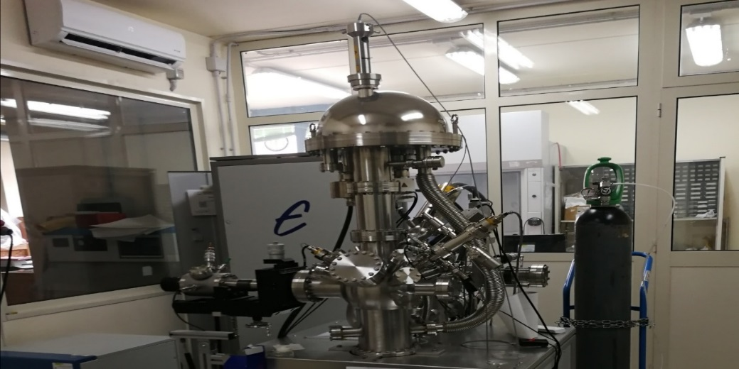
A view of the MCD-5 spectrometer Phoibos100 (SPECS) operative in the XPS laboratory (DiS)

More information are found on her web site: http://docenti.unibas.it/site/home.html
The relevant publications and Congress contributions reporting on XPS studies and surface analyses of the investigated materials of scientific and technological importance are retrievable at the following websites:
- Iris/UniBas data- base from http://docenti.unibas.it/site/home.html
- https://scholar.google.com/citations?user=XNp9cn0AAAAJ&hl=it&oi=ao.

